Exno:6

Date:

**SELECT with various clause – GROUP BY, HAVING, ORDER BY**

**AIM:**

To create a table, selecting rows using group by, order by.

1. **Create table project.**

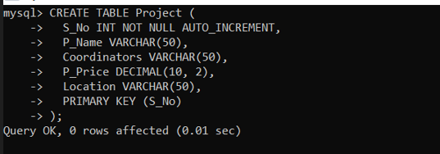

1. **Insert data into the table:**

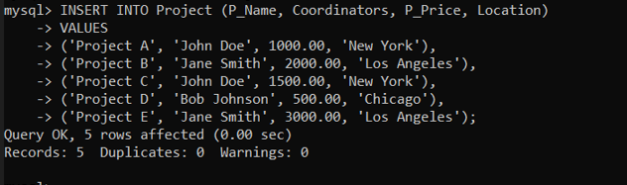

1. **Select the rows in the table using group by clause for location:**

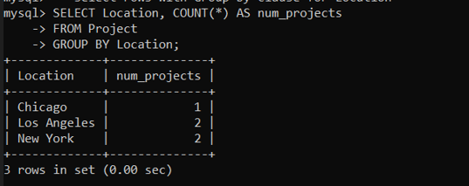

1. **Select the rows in the table order by coordinators:**

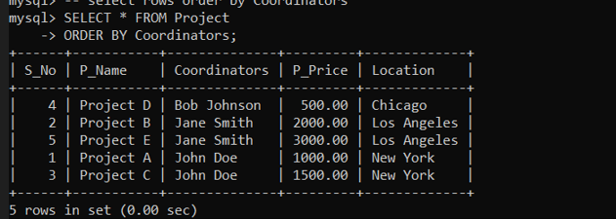

**Result:**

Table is created, the values are inserted, selected the rows using group by, order by clauses.